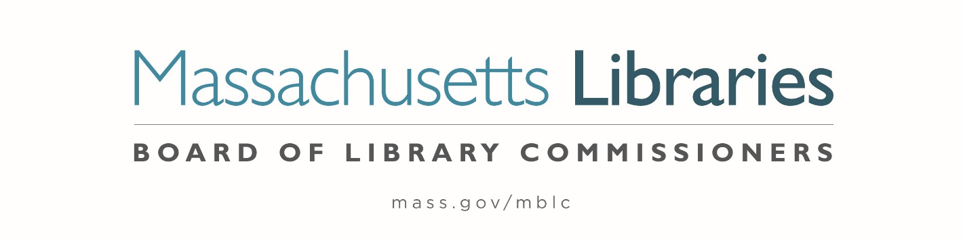

Welcome. Thank you for attending this meeting of the Massachusetts Board of Library Commissioners. Please remember that as part of the meeting agenda there is a time at the end of the meeting for public comment. Should you wish to address the Board during a particular item, please wait to be recognized by the chair.
Note: Agenda may include items not reasonably expected 48 hours before the meeting.
Thursday, October 8, 2020 10:00 A.M.
Zoom Meeting
https://zoom.us/j/93446393281?pwd=OXM4MmkvOXlJaS9rYjZaeXZ2bzdMQT09
Meeting ID: 934 4639 3281∙ Passcode: 308639
Dial in number: (646) 558-8656/ Meeting ID: 934 4639 3281
Agenda- Regular Monthly Meeting
- Call to Order

- Welcome

- Approval of Minutes- Regular Monthly Meeting September 3, 2020 (ACTION)

Speaker: Mary Ann Cluggish, Chair

- Chair’s Report

Speaker: Mary Ann Cluggish, Chair

- Commissioner Reports

Speaker: Mary Ann Cluggish, Chair

- Director’s Report

Speaker: James M. Lonergan, Director

Posted: Wednesday, September 30, 2020 at 4:00 P.M.
- Legislative Report

Speaker: Mary Rose Quinn, Head of State Programs/ Government Liaison

- Communications Update

Speaker: Celeste Bruno, Communications Director

- Consideration of approval of policies for the FY2023 State Aid to Public Libraries Program

- Extending a Grace Period for Increased Population-Based Minimum Standards (ACTION)
- Minimum Standards of Hours of Service for Public Libraries (ACTION)
- Minimum Materials Expenditure Standard Calculation (ACTION)
- Materials Expenditure and Hours Open Accommodation Policy (ACTION)
- Municipal Appropriation Requirement Calculation (ACTION)
- Determining Eligibility for a Waiver for the FY2023 Municipal Appropriation Requirement (ACTION)
- The Closure of a Public Library (ACTION)
- Five Year Waiver Plan Policy (ACTION)

Speaker: Liz Babbitt, State Aid Specialist

- Consideration of appointment to the State Advisory Council on Libraries (SACL) (ACTION)

Speaker: Rob Favini, Head of Library Advisory & Development

- Consideration of approval of two partial grant awards under the Massachusetts Public Library Construction Program (MPLCP) (ACTION)

Speaker: Lauren Stara, Library Building Specialist

- Presentation of Library Space: A Planning Resource for Librarians

Speakers: Lan Ying Ip, Architect and Principal Associate, Sasaki
Lauren Stara, Library Building Specialist
Andrea Bunker, Library Building Specialist

- Report from the Massachusetts Library System

Speaker: Sarah Sogigian, Executive Director
Massachusetts Library System (MLS)

- Report from Library for the Commonwealth

Speaker: Catherine Halpin, Collaborative Library Services Coordinator
Boston Public Library (BPL)

- Libraries and COVID-19 Discussion

Speakers: Mary Ann Cluggish, Chair
James Lonergan, Director
- Commissioner Activities

- Public Comment

- Old Business

- Adjournment Mary Ann Cluggish, Chair
To review the Massachusetts Board of Library Commissioners current bylaws
(Organizations and Functions of the Board of Library Commissioners)
Visit https://mblc.state.ma.us/about-us/commissioners/index.php

