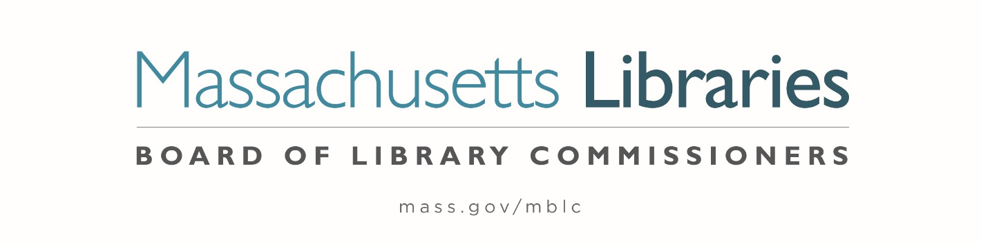

Welcome. Thank you for attending this meeting of the Massachusetts Board of Library Commissioners. Please remember that as part of the meeting agenda there is a time at the end of the meeting for public comment. Should you wish to address the Board during a particular item, please wait to be recognized by the chair.
Note: Agenda may include items not reasonably expected 48 hours before the meeting.
Thursday, November 5, 2020 10:00 A.M.
Zoom Meeting
https://us02web.zoom.us/j/87077438286?pwd=WWp5azNuYzB5NGFtZVFIRWVUUEN5UT09
Meeting ID: 870 7743 8286 ∙ Passcode: 088529
Dial in number: (646) 558-8656/ Meeting ID: 870 7743 8286
Agenda- Regular Monthly Meeting
- Call to Order

- Welcome

- Approval of Minutes- Regular Monthly Meeting September 3, 2020 (ACTION)

- Approval of Minutes- Regular Monthly Meeting October 8, 2020 (ACTION)

Speaker: Mary Ann Cluggish, Chair

- Chair’s Report

Speaker: Mary Ann Cluggish, Chair

- Commissioner Reports

Speaker: Mary Ann Cluggish, Chair


Posted: Monday, November 2, 2020 at 4:00 P.M.
- Director’s Report

Speaker: James M. Lonergan, Director

- Legislative Report

Speaker: Mary Rose Quinn, Head of State Programs/ Government Liaison

- Consideration of approval of the FY2022 Library Services and Technology Act (LSTA) Direct Grant Round Program & Budget (ACTION)

Speaker: Rob Favini, Head of Library Advisory & Development

- Consideration of Network Grant Awards under account 7000-9506
- FY2021 Small Libraries in Networks Recommendation (ACTION)
- FY2021 Telecommunications for Resource Sharing Recommendation (ACTION)
- FY2021 Network Infrastructure Recommendation (ACTION)
- FY2021 Resource Sharing Program Recommendation (ACTION)

Speaker: Paul Kissman, Library Information System Specialist

- Consideration of approval for the Library eBooks and Audiobooks (LEA) Content Grants (ACTION)

Speaker: Kate Butler, Electronic Systems Specialist

- Consideration of appointments to the Public Relations Committee (ACTION)

Speaker: Celeste Bruno, Communications Director

- Update to State Aid Applications and Waivers

Speaker: Liz Babbitt, State Aid Specialist

- Presentation of Library Space: A Planning Resource for Librarians

Speakers: Lan Ying Ip, Architect and Principal Associate, Sasaki
Lauren Stara, Library Building Specialist
Andrea Bunker, Library Building Specialist

- Report from the Massachusetts Library System

Speaker: Terry McQuown, Consulting and Training Services Director
Massachusetts Library System (MLS)

- Report from Library for the Commonwealth

Speaker: Catherine Halpin, Collaborative Library Services Coordinator
Boston Public Library (BPL)

- Libraries and COVID-19 Discussion

Speakers: Mary Ann Cluggish, Chair
James Lonergan, Director
- Commissioner Activities

- Public Comment

- Old Business

- Adjournment Mary Ann Cluggish, Chair

To review the Massachusetts Board of Library Commissioners current bylaws
(Organizations and Functions of the Board of Library Commissioners)
Visit https://mblc.state.ma.us/about-us/commissioners/index.php

