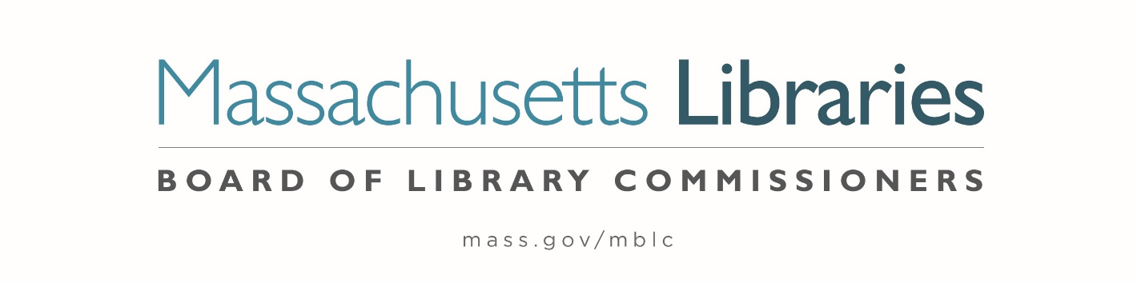

Welcome. Thank you for attending this meeting of the Massachusetts Board of Library Commissioners. Please remember that as part of the meeting agenda there is a time at the end of the meeting for public comment. Should you wish to address the Board during a particular item, please wait to be recognized by the chair.
Note: Agenda may include items not reasonably expected 48 hours before the meeting.
Thursday, May 6, 2021 10:00 A.M.
Zoom Meeting Information

https://us02web.zoom.us/j/87447796426?pwd=UlVsaFRrc0ppNEpaQXJVdytTZXNCdz09

Meeting ID: 874 4779 6426 ∙ Passcode: 504542

Dial in number: (646) 558-8656/ Meeting ID: 874 4779 6426

Agenda- Regular Monthly Meeting
- Call to Order- Roll Call of Commissioners
10:00- 10:02 A.M.
Speaker: Mary Ann Cluggish, Chair

- Approval of Minutes- April 1, 2021 Minutes (ACTION)
10:03 - 10:08 A.M.
Speaker: Mary Ann Cluggish, Chair

- Chair’s Report
10:09- 10:14 A.M.
Speaker: Mary Ann Cluggish, Chair

- Commissioner Reports
10:15- 10:20 A.M.
Speaker: Mary Ann Cluggish, Chair

- Director’s Report
10:21- 10:31 A.M.

Speaker: James M. Lonergan, Director
Posted: Posted: Thursday, April 29, 2021 at 5:00 P.M.

- Legislative Report
10:32- 10:37 A.M.

Speaker: Mary Rose Quinn, Head of State Programs/ Government Liaison

- Consideration of Joining Networks Grant Award Recommendation (ACTION)

10:38- 10:49 A.M.

Speaker: Paul Kissman, Library Information Systems Specialist

- Consideration of approval of a Massachusetts Public Library Construction Program (MPLCP) Provisional Grant Award for the Jones Library, Amherst (ACTION)

10:50- 11:00 A.M.

Speaker: Andrea Bunker, Library Building Specialist

- Consideration of approval for a MPLCP Small Library Pilot Project (ACTION)

11:01- 11:11 A.M.

Speaker: Lauren Stara, Library Building Specialist

- Report from Massachusetts Library System (MLS)
11:12- 11:17 A.M.
Speaker: Sarah Sogigian, Executive Director
Massachusetts Library System (MLS)

- Report from the Library for the Commonwealth (LFC)
11:18- 11:23 A.M.
Speaker: Catherine Halpin, Collaborative Library Services Coordinator
Boston Public Library (BPL)

- Libraries and COVID-19 Discussion
11:24- 11:29 A.M.
Speakers: Mary Ann Cluggish, Chair
James Lonergan, Director

- Public Comment 11:30- 11:35 A.M.

- Old Business 11:36- 11:41 A.M.

- Adjournment Mary Ann Cluggish, Chair

To review the Massachusetts Board of Library Commissioners current bylaws
(Organizations and Functions of the Board of Library Commissioners)
Visit https://mblc.state.ma.us/about-us/commissioners/index.php

