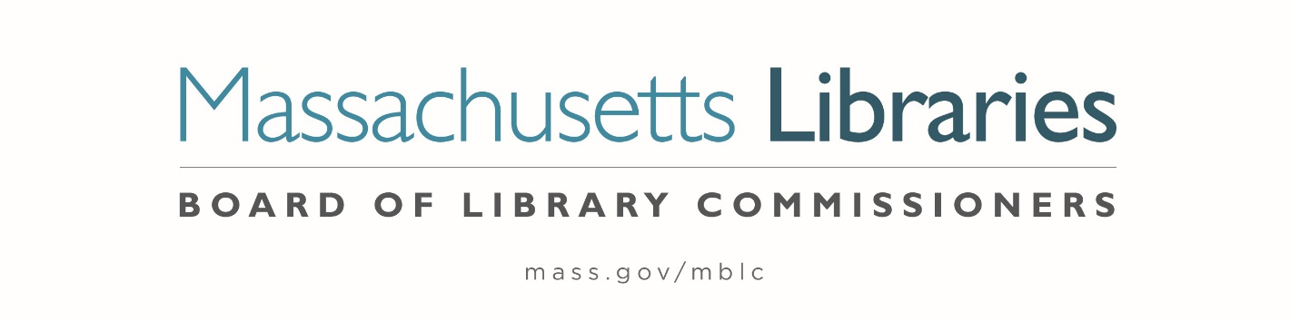

Welcome. Thank you for attending this meeting of the Massachusetts Board of Library Commissioners. Please remember that as part of the meeting agenda there is a time at the end of the meeting for public comment. Should you wish to address the Board during a particular item, please wait to be recognized by the chair.
Note: Agenda may include items not reasonably expected 48 hours before the meeting.
Thursday, March 4, 2021 10:00 A.M.
Zoom Meeting Information

https://us02web.zoom.us/j/89335503549?pwd=UUVVZ1R0YXo3SHhsSEN2WUtBTmFUUT09

Meeting ID: 893 3550 3549 ∙ Passcode: 563680

Dial in number: (646) 558-8656/ Meeting ID: 893 3550 3549

Agenda- Regular Monthly Meeting
- Call to Order- Roll Call of Commissioners
10:00- 10:02 A.M.
Speaker: Mary Ann Cluggish, Chair

- Approval of Minutes- February 4, 2021 Minutes (ACTION)
10:03 - 10:08 A.M.
Speaker: Mary Ann Cluggish, Chair

- Chair’s Report
10:09- 10:14 A.M.
Speaker: Mary Ann Cluggish, Chair

- Commissioner Reports
10:15- 10:20 A.M.
Speaker: Mary Ann Cluggish, Chair

- Director’s Report
10:21- 10:31 A.M.

Speaker: James M. Lonergan, Director
Posted: Thursday, February 25, 2021 at 12:00 P.M.

- Legislative Report
10:32- 10:37 A.M.

Speaker: Mary Rose Quinn, Head of State Programs/ Government Liaison

- Consideration of approval of the municipality meeting the requirements for the FY2021 State Aid to Public Libraries based on eligibility established in FY2021 for the Municipal Appropriation Requirement and in FY2020 for the minimum standards (ACTION)

10:38- 10:43 A.M

Speaker: Liz Babbitt, State Aid Specialist

- Consideration of approval of the municipalities requesting waivers for the FY2021 municipal appropriation requirement in the FY2021 State Aid to Public Libraries Program within the 10% threshold (ACTION)
10:44- 10:54 A.M.

Speaker: Mary Rose Quinn, Head of State Programs/ Government Liaison

5 Minute Break- 10:55- 11:00 A.M.

- Consideration of approval of petitions for waivers of the municipal appropriation requirements for the FY2021 State Aid to Public Libraries above the 10% threshold

- Stoneham -11.35% (ACTION) 11:01- 11:11 A.M.
- Kingston -12.45% (ACTION) 11:12- 11:22 A.M.
- Hanover -12.52% (ACTION) 11:23- 11:33 A.M.
- Oxford -18.01% (ACTION) 11:34- 11:44 A.M.

Speaker: Mary Rose Quinn, Head of State Programs/ Government Liaison

- Presentation and discussion of the FY2022 Plan of Service and Program and Budget for the Massachusetts Center for the Book and Monthly Report
11:45- 11:55 A.M.

Speakers: Sharon Shaloo, Executive Director
Massachusetts Center for the Book
Krista McLeod, Director, Nevins Memorial Library, Methuen
Board Member, Massachusetts Center for the Book
- Report from Massachusetts Library System (MLS)
11:56 A.M.- 12:01 P.M.
Speaker: Sarah Sogigan, Executive Director
Massachusetts Library System (MLS)

- Report from the Library for the Commonwealth (LFC)
12:02- 12:07 P.M.
Speaker: Catherine Halpin, Collaborative Library Services Coordinator
Boston Public Library (BPL)

- Libraries and COVID-19 Discussion
12:08- 12:18 P.M.
Speakers: Mary Ann Cluggish, Chair
James Lonergan, Director

- Public Comment 12:19- 12:24 P.M.

- Old Business 12:25- 12:30 P.M.

- Adjournment Mary Ann Cluggish, Chair

To review the Massachusetts Board of Library Commissioners current bylaws
(Organizations and Functions of the Board of Library Commissioners)
Visit https://mblc.state.ma.us/about-us/commissioners/index.php

