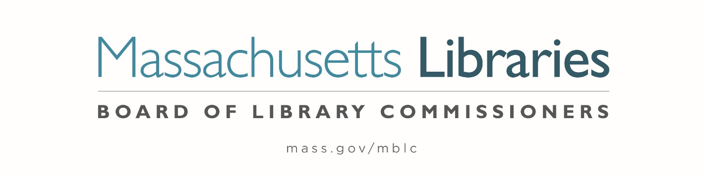

Welcome. Thank you for attending this meeting of the Massachusetts Board of Library Commissioners. Please remember that as part of the meeting agenda there is a time at the end of the meeting for public comment. Should you wish to address the Board during a particular item, please wait to be recognized by the chair.
Note: Agenda may include items not reasonably expected 48 hours before the meeting.
Thursday, June 3, 2021 10:00 A.M.
Zoom Meeting Information

https://us02web.zoom.us/j/87635339369?pwd=UnB2ZHVBclhpUE93U3Fja3kxTVVUUT09

Meeting ID: 876 3533 9369 ∙ Passcode: 424588

Dial in number: (646) 558-8656/ Meeting ID: 876 3533 9369

Agenda- Regular Monthly Meeting
- Call to Order- Roll Call of Commissioners
10:00- 10:02 A.M.
Speaker: Mary Ann Cluggish, Chair

- Approval of Minutes- May 6, 2021 Minutes (ACTION)
10:03 - 10:08 A.M.
Speaker: Mary Ann Cluggish, Chair

- Chair’s Report
10:09- 10:14 A.M.
Speaker: Mary Ann Cluggish, Chair

- Commissioner Reports
10:15- 10:25 A.M.
Speaker: Mary Ann Cluggish, Chair

- Director’s Report
10:26- 10:36 A.M.

Speaker: James M. Lonergan, Director
Posted: Posted: Thursday, May 27, 2021 at 5:00 P.M.

- Legislative Report
10:37- 10:42 A.M.

Speaker: Mary Rose Quinn, Head of State Programs/ Government Liaison

- Consideration of approval of three Massachusetts Public Library Construction Program (MPLCP) Partial Provisional Grant Awards (ACTION)
10:43- 10:53 A.M.

Speaker: Lauren Stara, Library Building Specialist

- Consideration of a FY2021 Grant Round for 7000-9506, Library Technology and Resource Sharing, including Telecommunications for Resource Sharing, Resource Sharing Program, Network Infrastructure, and Small Libraries in Networks (ACTION)
10:54- 11:04 A.M.

Speaker: Paul Kissman, Library Information Systems Specialist

- Consideration of a FY2021 Grant Round for 7000-9506, LEA eContent grants (ACTION) 11:05- 11:15 A.M.

Speaker: Kate Butler, Electronic Services Specialist

- Update on FY2023 Database Procurement Activities and Survey Results
11:16- 11:26 A.M.

Speaker: Kate Butler, Electronic Services Specialist

- Discussion of State Aid Hours Open Requirement
11:27- 11:37 A.M.

Speaker: Mary Rose Quinn, Head of State Programs/ Government Liaison

- Report from Massachusetts Library System (MLS)
11:38- 11:43 A.M.
Speaker: Sarah Sogigian, Executive Director
Massachusetts Library System (MLS)

- Report from the Library for the Commonwealth (LFC)
11:44- 11:49 A.M.
Speaker: Catherine Halpin, Collaborative Library Services Coordinator
Boston Public Library (BPL)

- Libraries and COVID-19 Discussion
11:50- 11:55 A.M.
Speakers: Mary Ann Cluggish, Chair
James Lonergan, Director

- Public Comment 11:56 A.M.- 12:01 P.M.

- Old Business 12:02- 12:07 P.M.

- Adjournment Mary Ann Cluggish, Chair

To review the Massachusetts Board of Library Commissioners current bylaws
(Organizations and Functions of the Board of Library Commissioners)
Visit https://mblc.state.ma.us/about-us/commissioners/index.php

