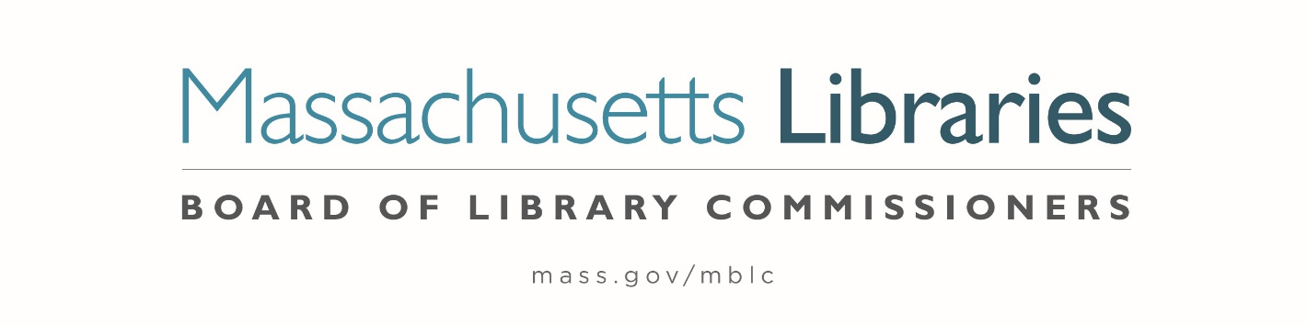

Welcome. Thank you for attending this meeting of the Massachusetts Board of Library Commissioners. Please remember that as part of the meeting agenda there is a time at the end of the meeting for public comment. Should you wish to address the Board during a particular item, please wait to be recognized by the chair.
Note: Agenda may include items not reasonably expected 48 hours before the meeting.
Thursday, January 7, 2021 10:00 A.M.
Zoom Meeting Information

https://us02web.zoom.us/j/87500909375?pwd=b2crUU5QcUovQmZmVDhPTi9tVjBoQT09

Meeting ID: 875 0090 9375 ∙ Passcode: 492716

Dial in number: (646) 558-8656/ Meeting ID: 875 0090 9375

Agenda- Regular Monthly Meeting
- Call to Order- Roll Call of Commissioners 2 Minutes

Speaker: Mary Ann Cluggish, Chair

- Approval of Minutes 10 Minutes

- Regular Monthly Meeting Minutes- December 3, 2020 (ACTION)

- Special Meeting- December 17, 2020 (ACTION)

Speaker: Mary Ann Cluggish, Chair

- Chair’s Report 5 Minutes

Speaker: Mary Ann Cluggish, Chair

- Commissioner Reports 5 Minutes


Speaker: Mary Ann Cluggish, Chair
Posted: Thursday, December 31, 2020 at 5:00 P.M.
- Director’s Report 10 Minutes

Speaker: James M. Lonergan, Director

- Legislative Report 5 Minutes

Speaker: Mary Rose Quinn, Head of State Programs/ Government Liaison

- Update to State Aid Policies for 2021 that impact 2022 (ACTION) 10 Minutes

Speaker: Mary Rose Quinn, Head of State Programs/ Government Liaison
Liz Babbitt, State Aid Specialist
- Approval of the FY2022 Legislative Agenda (ACTION) 10 Minutes

Speaker: Mary Ann Cluggish, Chair
James Lonergan, Director
Mary Rose Quinn, Head of State Programs/ Government Liaison

- Consideration of approval of the FY2022 Plan of Service and Program and Budget for the Massachusetts Library System (ACTION) 10 Minutes

Speaker: Sarah Sogigian, Executive Director
Massachusetts Library System (MLS)

- Presentation and discussion of the FY2022 Plan of Service and Program and Budget for the Library for the Commonwealth (ACTION) 10 Minutes

Speaker: Anna Fahey-Flynn, Manager of the Central Library
Catherine Halpin, Collaborative Library Services Coordinator
Boston Public Library (BPL)

- Report from Massachusetts Library System (MLS) 5 Minutes

Speaker: Sarah Sogigan, Executive Director
Massachusetts Library System (MLS)

- Report from the Library for the Commonwealth (LFC) 5 Minutes

Speaker: Catherine Halpin, Collaborative Library Services Coordinator
Boston Public Library (BPL)

- Libraries and COVID-19 Discussion 10 Minutes

Speakers: Mary Ann Cluggish, Chair
James Lonergan, Director
- Commissioner Activities 5 Minutes

- Public Comment 5 Minutes

- Old Business 5 Minutes

- Adjournment Mary Ann Cluggish, Chair

To review the Massachusetts Board of Library Commissioners current bylaws
(Organizations and Functions of the Board of Library Commissioners)
Visit https://mblc.state.ma.us/about-us/commissioners/index.php

