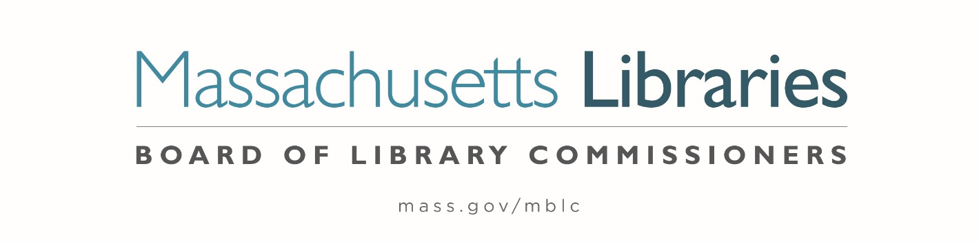

Welcome. Thank you for attending this meeting of the Massachusetts Board of Library Commissioners. Please remember that as part of the meeting agenda there is a time at the end of the meeting for public comment. Should you wish to address the Board during a particular item, please wait to be recognized by the chair.
Note: Agenda may include items not reasonably expected 48 hours before the meeting.
Thursday, February 4, 2021 10:00 A.M.
Zoom Meeting Information

https://us02web.zoom.us/j/89157947316?pwd=QkZlV3ZrMGtjSHZiR0lFemhXSU5Gdz09

Meeting ID: 891 5794 7316 ∙ Passcode: 117107

Dial in number: (646) 558-8656/ Meeting ID: 891 5794 7316

Agenda- Regular Monthly Meeting
- Call to Order- Roll Call of Commissioners
10:00- 10:02 A.M.
Speaker: Mary Ann Cluggish, Chair

- Approval of Minutes- January 7, 2021 Minutes (ACTION)
10:03 - 10:08 A.M.
Speaker: Mary Ann Cluggish, Chair

- Chair’s Report
10:09- 10:14 A.M.
Speaker: Mary Ann Cluggish, Chair

- Commissioner Reports
10:15- 10:20 A.M.
Speaker: Mary Ann Cluggish, Chair

- Director’s Report
10:21- 10:31 A.M.

Speaker: James M. Lonergan, Director
Posted: Thursday, January 28, 2021 at 5:00 P.M.
- Legislative Report
10:32- 10:37 A.M.

Speaker: Mary Rose Quinn, Head of State Programs/ Government Liaison

- Consideration of approval of the municipalities meeting the requirements for the FY2021 State Aid to Public Libraries based on eligibility established in FY2021 for the Municipal Appropriation Requirement and in FY2020 for the minimum standards (ACTION)

10:38- 10:48 A.M

Speaker: Liz Babbitt, State Aid Specialist

- Review of municipalities requesting waivers for the FY2021 municipal appropriation requirement in the FY2021 State Aid to Public Libraries Program within the 10% threshold
10:49- 10:59 A.M.

Speaker: Mary Rose Quinn, Head of State Programs/ Government Liaison

5 Minute Break- 11:00- 11:05 A.M.

- Review and presentations of petitions for waivers of the municipal appropriation requirements for the FY2021 State Aid to Public Libraries above the 10% threshold

11:05-11:08 A.M.

Speaker: Mary Rose Quinn, Head of State Programs/ Government Liaison

- Stoneham: -11.35% 11:09- 11:19 A.M.
- Kingston: -12.45% 11:20- 11:30 A.M.
- Hanover: -12.52% 11:31- 11:41 A.M.
- Oxford: -18.01% 11:42- 11:52 A.M.

5 Minute Break- 11:53- 11:58 A.M.

- Report from Massachusetts Library System (MLS)
11:59 A.M.- 12:04 P.M.
Speaker: Sarah Sogigan, Executive Director
Massachusetts Library System (MLS)
- Report from the Library for the Commonwealth (LFC)
12:05- 12:10 P.M.
Speaker: Catherine Halpin, Collaborative Library Services Coordinator
Boston Public Library (BPL)

- Libraries and COVID-19 Discussion
12:11- 12:21 P.M.
Speakers: Mary Ann Cluggish, Chair
James Lonergan, Director

- Commissioner Activities 12:22- 12:27 P.M.

- Public Comment 12:28- 12:33 P.M.

- Old Business 12:34- 12:39 P.M.

- Adjournment Mary Ann Cluggish, Chair

To review the Massachusetts Board of Library Commissioners current bylaws
(Organizations and Functions of the Board of Library Commissioners)
Visit https://mblc.state.ma.us/about-us/commissioners/index.php

