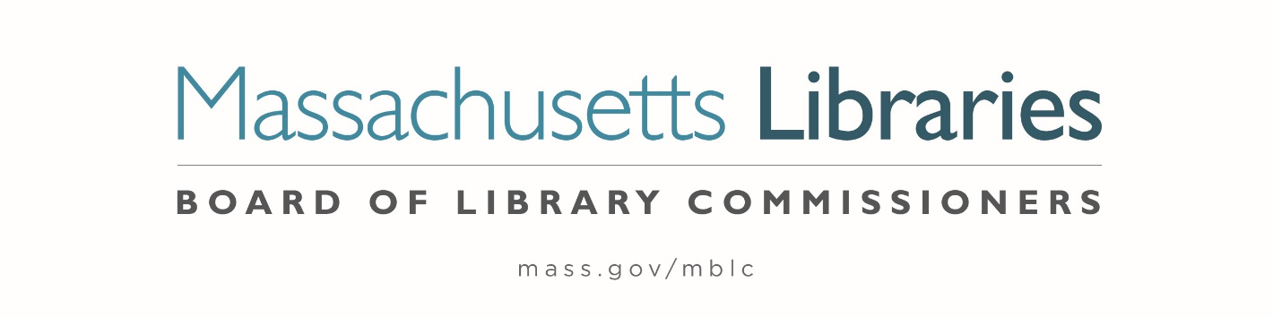

Welcome. Thank you for attending this meeting of the Massachusetts Board of Library Commissioners. Please remember that as part of the meeting agenda there is a time at the end of the meeting for public comment. Should you wish to address the Board during a particular item, please wait to be recognized by the chair.
Note: Agenda may include items not reasonably expected 48 hours before the meeting.
Thursday, December 3, 2020 10:00 A.M.
Zoom Meeting
https://us02web.zoom.us/j/87340472570?pwd=d21ZUWZVOWdTbEpRdXZuMndWQWJ3UT09
Meeting ID: 873 4047 2570 ∙ Passcode: 875065
Dial in number: (646) 558-8656/ Meeting ID: 873 4047 2570
Agenda- Regular Monthly Meeting
- Call to Order

- Welcome

- Approval of Minutes- Regular Monthly Meeting November 5, 2020 (ACTION)

Speaker: Mary Ann Cluggish, Chair

- Chair’s Report

Speaker: Mary Ann Cluggish, Chair

- Commissioner Reports

Speaker: Mary Ann Cluggish, Chair

- Director’s Report

Speaker: James M. Lonergan, Director

Posted: Wednesday, November 25, 2020 at 4:00 P.M.
- Legislative Report

Speaker: Mary Rose Quinn, Head of State Programs/ Government Liaison

- Communications Update

Speaker: Celeste Bruno, Communications Director

- Update on State Aid to Public Libraries Waivers

Speaker: Mary Rose Quinn, Head of State Programs/ Government Liaison

- Preliminary Discussion of the FY2022 Legislative Agenda

Speaker: Mary Ann Cluggish, Chair
James Lonergan, Director
Mary Rose Quinn, Head of State Programs/ Government Liaison

- Presentation and discussion of the FY2022 Plan of Service and Program and Budget for the Massachusetts Library System and Monthly Report

Speaker: Sarah Sogigian, Executive Director
Massachusetts Library System (MLS)

- Presentation and discussion of the FY2022 Plan of Service and Program and Budget for the Library for the Commonwealth and Monthly Report

Speaker: Anna Fahey-Flynn, Manager of the Central Library
Catherine Halpin, Collaborative Library Services Coordinator
Boston Public Library (BPL)

- Libraries and COVID-19 Discussion

Speakers: Mary Ann Cluggish, Chair
James Lonergan, Director
- Commissioner Activities

- Public Comment

- Old Business

- MBLC Years of Service Pins
- Matt Perry, 5 Years
- Amy Clayton, 20 Years
- Rachel Masse, 20 Years
- Paul Kissman, 25 Years

- Adjournment Mary Ann Cluggish, Chair

To review the Massachusetts Board of Library Commissioners current bylaws
(Organizations and Functions of the Board of Library Commissioners)
Visit https://mblc.state.ma.us/about-us/commissioners/index.php

