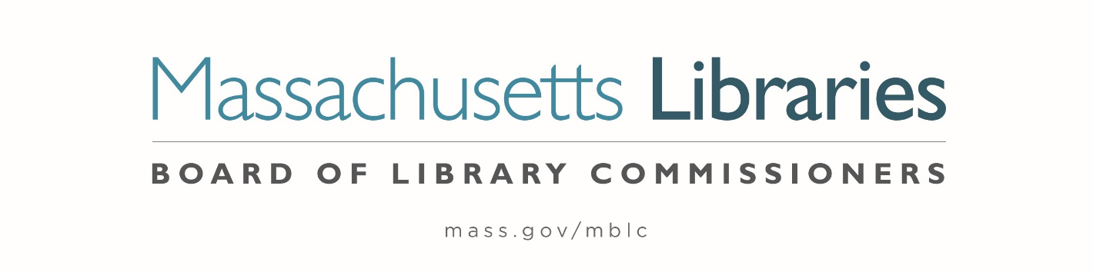

Welcome. Thank you for attending this meeting of the Massachusetts Board of Library Commissioners. Please remember that as part of the meeting agenda there is a time at the end of the meeting for public comment. Should you wish to address the Board during a particular item, please wait to be recognized by the chair.
Note: Agenda may include items not reasonably expected 48 hours before the meeting.
Thursday, December 17, 2020 1:00 P.M.
Zoom Meeting
https://us02web.zoom.us/j/84317795517?pwd=VzRMUGJUZGxwUlF1RnpkRlhVdjJ3Zz09
Meeting ID: 843 1779 5517 ∙ Passcode: 340632
Dial in number: (646) 558-8656/ Meeting ID: 843 1779 5517
Agenda- Special Meeting
- Call to Order

- Roll Call

Speaker: Mary Ann Cluggish, Chair

- Discussion and consideration of the MBLC’s Strategic Plan 2021-2025 (ACTION)

Speaker: Abby Straus, Consultant, Maverick & Boutique
Mary Ann Cluggish, Chair
James M. Lonergan, Director

- Adjournment Mary Ann Cluggish, Chair


Posted: Thursday, December 10, 2020 at 4:00 P.M.
- Legislative Report

