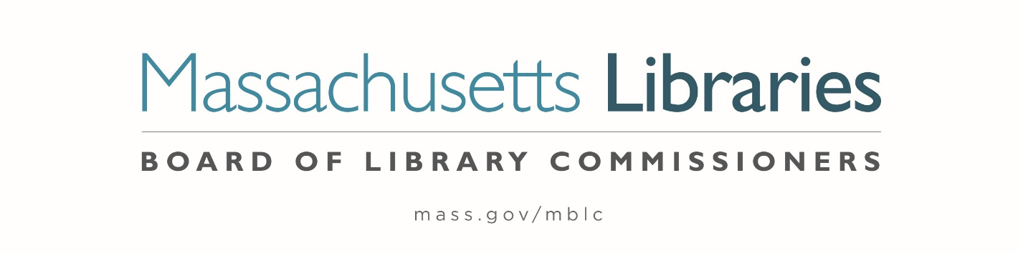

Welcome. Thank you for attending this meeting of the Massachusetts Board of Library Commissioners. Please remember that as part of the meeting agenda there is a time at the end of the meeting for public comment. Should you wish to address the Board during a particular item, please wait to be recognized by the chair.
Note: Agenda may include items not reasonably expected 48 hours before the meeting.
Thursday, April 1, 2021 10:00 A.M.
Zoom Meeting Information

https://us02web.zoom.us/j/84191697383?pwd=bkdhZTI0dlgxMGFGdHkwajUzMnNMdz09

Meeting ID: 841 9169 7383∙ Passcode: 236416

Dial in number: (646) 558-8656/ Meeting ID: 841 9169 7383

Agenda- Regular Monthly Meeting
- Call to Order- Roll Call of Commissioners
10:00- 10:02 A.M.
Speaker: Mary Ann Cluggish, Chair

- Approval of Minutes- March 4, 2021 Minutes (ACTION)
10:03 - 10:08 A.M.
Speaker: Mary Ann Cluggish, Chair

- Chair’s Report
10:09- 10:14 A.M.
Speaker: Mary Ann Cluggish, Chair

- Commissioner Reports
10:15- 10:20 A.M.
Speaker: Mary Ann Cluggish, Chair

- Director’s Report
10:21- 10:31 A.M.

Speaker: James M. Lonergan, Director
Posted: Posted: Thursday, March 25, 2021 at 1:00 P.M.

- Legislative Report
10:32- 10:37 A.M.

Speaker: Mary Rose Quinn, Head of State Programs/ Government Liaison

- Consideration of appointment to the State Advisory Council on Libraries (SACL) (ACTION)
10:38- 10:48 A.M.

Speaker: Rob Favini, Head of Library Advisory & Development

- Consideration of approval of the FY2022 Plan of Service and Program and Budget for the Massachusetts Center for the Book (ACTION)
10:49- 10:54 A.M.

Speakers: Sharon Shaloo, Executive Director
Massachusetts Center for the Book
Krista McLeod, Director, Nevins Memorial Library, Methuen
Board Member, Massachusetts Center for the Book

- Report from Massachusetts Library System (MLS)
10:55- 11:00 A.M.
Speaker: Sarah Sogigan, Executive Director
Massachusetts Library System (MLS)

- Report from the Library for the Commonwealth (LFC)
11:01- 11:06 A.M.
Speaker: Catherine Halpin, Collaborative Library Services Coordinator
Boston Public Library (BPL)

- Libraries and COVID-19 Discussion
11:07- 11:12 A.M.
Speakers: Mary Ann Cluggish, Chair
James Lonergan, Director

- Public Comment 11:13- 11:18 A.M.

- Old Business 11:19- 11:24 A.M.

- Adjournment Mary Ann Cluggish, Chair

To review the Massachusetts Board of Library Commissioners current bylaws
(Organizations and Functions of the Board of Library Commissioners)
Visit https://mblc.state.ma.us/about-us/commissioners/index.php

